

**GROUP MEMBERS**

1. SYED MUSTAFA HASSAN. ***SUBMITTED TO***
2. AMMAD ABDUL LATIF MISS ASMA CHANG.
3. HASSAN FASIAL.

PRINCIPLE OF MANAGEMENT (FINAL PROJECT)

DATE: 14/1/22

**INTRODUCTION**

In this project we supposed to go any organization to analysis of the organization, so after a long discussion in our group we decided go to ***Honda Company*** to get our goals. We successfully get the enters to go ahead. The meeting is set on 12/1/21.

**GROUP MEMBERS**

|  |  |  |
| --- | --- | --- |
| **No.** | **NAME** | **ID** |
| 1 | SYED MUSTAFA HASSAN (G.L) | FA21-BSCS-0030 |
| 2 | AMMAD ABDUL LATIF | FA21-BSCS-0013 |
| 3 | HASSAN FASIAL | FA21-BSCS-0021 |

**OUR STRATEGY:**

In start of this project we face many problems like how to do this project, which member did what, what company we take for this project, did company give us permission, what type of question we asked to the manager, how to manage our report and many other like these so firstly we set our group meeting to decide that how to solve these problems we discuss a lot on the solution we find many solutions and me made a list of our solutions then analysis that which solution is the best for achieving our goal we made many alternatives for making backward strategy then finally we apply the one the best solution in a way that the solution make an good impartation of us to the company. In the last we evaluate our solution and we a good result.

**LIST OF QUESTIONS:**

Q1. How many departments in this company?

Q2. How many employees are there in this company?

Q3. What is background of this company?

Q4. How many branches of your company?

Q5. What is your mission and vision?

Q6. What type of services you provide in the market?

Q7. What is the organizational structure of the company?

Q8. What is the macro environment?

Q9. Who are your competitor?

Q10. What are the requirements to get job in this company?

Q11. What are skills you want to see in a candidate to giving him/her job in your organization?

Q12. What are the rules and policy on which you hire the employees?

Q13. What are the benefits you give to your employees?

Q14. How did you make any strategies?

Q15. Then how did you implement it?

Q16. How did you evaluate your strategies?

Q17. How much you are effect by the government policy?

Q18. What are the changes you do to more improvements?

Q19.How did you make any strategy?

Q20.How you implement your strategy?

Q21.How you evaluate your strategy?

Q22.Did you take the advice with your employees while make any changes?

Q23.What is environment in your organization?

Q24.What benefits you provide to your employees?

Q25.What the thing which make your different for others?

Q26.How did you compete your competitors?

Q27. How do you motivate yourself?

Q28. How do you manage your workload?

Q29. What is the most challenging thing about being a manager?

Q30.What you are Preparations for the future?

Q30.Where do you see your organization after five years?

**INTRODUCTION OF HONDA:**

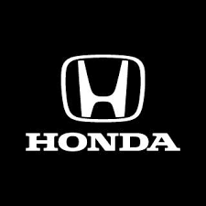

**HONDA** is the one of the biggest company who make different automobiles, they are in all over the world they just work on automobile’s they are also famous in market by name “Honda Ring Road”. Honda Ring Road is an authorized 3S facility certified by Honda Atlas Cars Pakistan Ltd. (HACPL). We are the most technically advanced and modern dealership in Pakistan, with space for over 120 car bays and the most advanced machinery and technology of any dealership in Pakistan. We are located 1 Km off Firozpur Road, near the Bhullay Shah interchange of Ring Road.

Their sales staff carry decades of experience collectively and are well-equipped both in mind, skill and technology to cater to your every need.

Their workshop staff is equipped with the finest tools, equipment and state of the art machinery available for the first time in Pakistan to solve any and every problem that your car may face. Using Honda Genuine parts and sophisticated technology and software, our trained t echnicians will do whatever they can to satisfy your demands and guarantee your 100% satisfaction with the quality of work done to your car. They have constructed a dedicated and specially designed customer waiting area for our customers to relax while their car is getting serviced by playing some video games, watching TV, playing table tennis or having some refreshments.

They are dedicated to providing you with the best car buying and maintenance experience of any dealership in Pakistan, using expert staff, state of the art equipment, sophisticated software and comfortable waiting area.

**Honda Quality Services**

Honda offers nothing but the highest quality services and workmanship thanks to our state-of-the-art machinery and top of the line equipment. Our experienced technical staff with years of expertise will make sure that your car is getting the tender love and care it deserves.

**Denting and Painting:**

Boasting a state-of-the-art paint booth, spot welding machinery and superb technical staff, Honda Ring Road is able to provide you with unrivalled denting, paint matching, and panel painting. The quality of denting and painting is unrivalled when it comes to Honda Ring Road.

* Paint Matching
* Panel Painting
* Denting

**Engine Repair:**

Honda Ring Road features a dedicated engine room with specialized machinery and licensed mechanics specifically trained to deal with all kinds of engine and mechanical problems. Using sophisticated scanning and monitoring tools, our technicians can easily diagnose and fix any part of your engine with speed and quality.

**Car Inspection:**

Get your car professionally inspected by our licensed mechanics using state-of-the-art imported scanners to diagnose any and every problem your car has in a matter of minutes. From an engine problem to minor electrical faults our top-notch machinery can easily diagnose your car without any intrusive operations.

Many other services…

**THEIR MOST FAMOUS PRODUCTS:**

* **Honda civic.**

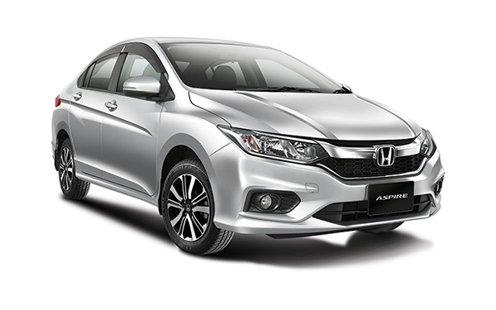

* **Honda city.**

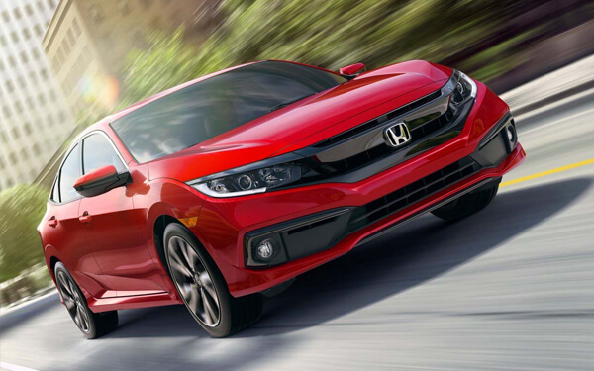

* **Honda accord.**

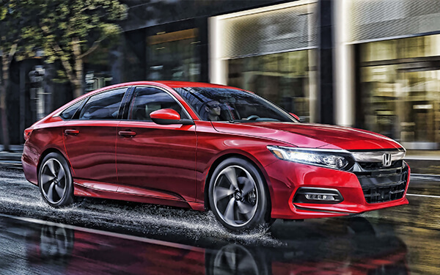

* **Honda BRV.**

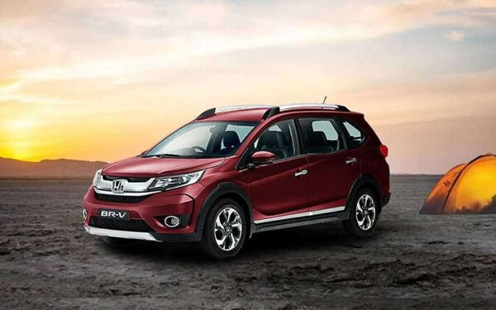

**Honda Karachi campus:**

**Address**: 13 Shahrah-e-Faisal, Bangalore Town Darwaish Colony, Karachi, Karachi City, Sindh.

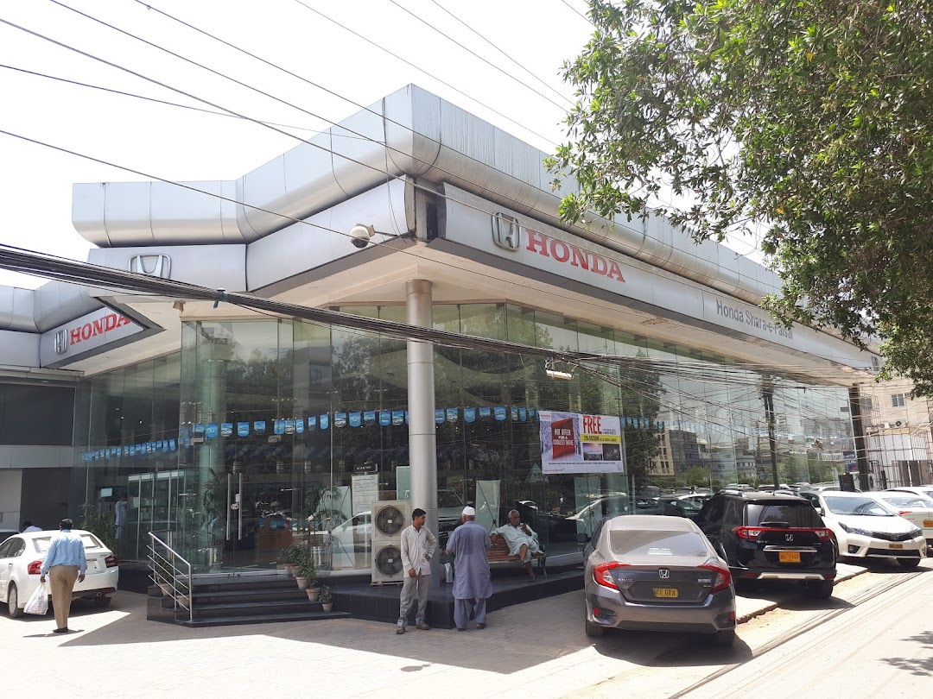

**Top – manager:**

*“Sheikh Moiz Amjad”*

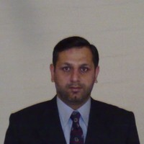

**DEPARTMENTS:**

There are seven departments in the company.

1. Casting Plant.
2. Paint Shop.
3. HR Departments.
4. Finance & Accounts.
5. IT Department.
6. Maintenance.
7. Selling.

**EMPLOYEES:**

There are 135 employees in that company in which two are top-line manager and three members are middle manager and 2 assistant managers. And rest of those are the worker and employees of Honda company.

**BACKGROUND OF HONDA:**

Honda has been the world's largest automobiles manufacturer since 1959, reaching a production of 400 million by the end of 2019, as well as the world's largest manufacturer of internal combustion engines measured by volume, producing more than 14 million internal combustion engines each year. Honda became the second-largest Japanese automobile manufacturer in 2001. Honda was the eighth largest automobile manufacturer in the world in 2015.They are doing the public multinational conglomerate manufacturer of automobiles, motorcycles, and power equipment, headquartered in Minato, Tokyo, Japan.

**BRANCHES IN KARACHI:**

There are seven branches in Karachi which are located in different places in Karachi.

**MISSION & VISION STATEMENT OF HONDA:**

**VISION:**

**“***Market leader in the motorcycle industry, emerging as a global competitive center of production and exports*.”

**MISSION:**

Honda mission statement is “***maintaining a global viewpoint, we are dedicated to supplying products of the highest quality, yet at a reasonable price for worldwide customer satisfaction***.” The statement shows that the value of the products that the company supplies top the list of its priorities.

**HONDA SERVICES:**

* Honda Autos.
* Acura Autos.
* Honda Powers ports.
* Honda Power Equipment.
* Honda Engines.
* Honda Marine.
* Honda Jet.
* ASIMO.

**ORGANIZATIONAL STRUCTURE OF HONDA**

Currently, Honda's automobile business is being operated with a collaborative structure where each area of S-E-D-B (Sales, Engineering/production, Development and Buying/purchasing) maintains autonomy and works in collaboration.

**FUNCTIONAL DEPARTMENTALIZATION OF HONDA:**

**(OWNER)**

**Saquib H. Shirazi**

**CEO**

**Sheikh Shiraz Mubashir**

**CEO**

**Sheikh Moniz Amjad**

**Rashid Ahmed**

Manager Commercial & Planning

**Mr. Muhammad Rashad**

Manager Human Resources

**Faisal Mahmud**

Manager New Model Center

**Muhammad Noman Khan**

Manager Engineering & Projects

nn

**THE 129 EMPLOYEES ARE DONING WORK UNDER THSES MANAGERS**

**ORGANIZATIONAL CHART:**

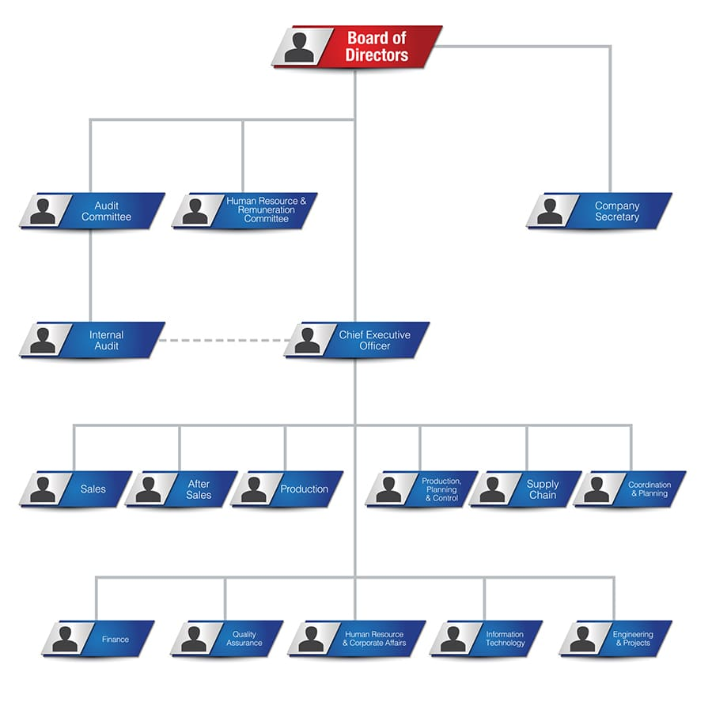

**MACRO ENVIRONMENT:**

When we asked about macro environment of **HONDA COMPANY** to their manager he state that:

“*Changes in the macro-environment factors can have a direct impact on not only the Honda Motor, but also can impact other players in the Auto Manufacturers - Major. The macro-environment factors can impact the Porter Five Forces that shape strategy and competitive landscape. They can impact individual firm’s competitive advantage or overall profitability levels of the Consumer Goods industry.*”

**HONDA COMPETITORS**

Honda's top competitors include

* Toyota
* Suzuki
* KIA

Honda stated that the rest of the other car companies in Pakistan they are not have that customer power which we have so they are not in the list of our competitors.

**JOB CRITERIA:**

Firstly, they do the marketing that they post the job adds on social media platform then they shortlist the selected persons then they take interview of those in which they skimming those people then finally then they give the job to those peoples which are pass in all test of selection.

**Education: Experience:**

Bachelor's and master. 1-more year.

**EMPLOYEES BENEFITS**

Employee benefits, also known as perks or fringe benefits, are provided to employees over and above salaries and wages. These employees benefit packages may include **overtime, medical insurance, vacation, profit sharing and retirement benefits**, to name just a few.

***Employee benefit examples:***

* Remote work.
* Healthcare.
* Paid time off.
* Flexible hours.
* Paid family leave.
* Four-day work week.
* Free food in the office.
* Student loan assistance.

**WHAT STRATEGY DOES HONDA USE?**

Honda has brought several attractive product models to the market. It has also used **a smart marketing strategy** with focus upon creating a reliable image and trust among the customers. It uses both traditional and digital methods of promotion to promote its brand and products. Honda company do not take the advice to the lower employees they all doing with head of office senior manager and director only while making any strategy.

**HONDA STRATEGY IN COVID:**

Honda would like to express its deepest sympathy and condolences to the victims and families of COVID-19 all around the world and the sincere hope for the earliest possible recovery for all those who are now fighting infection.

Whether it be on the medical front line, or supporting our daily lives through various services, many people are giving their all in these difficult times.

Honda too, by way of our products, technologies, and people, will undertake everything that we can do by globally uniting our associates from all over the world while staying close to our local communities.

We hope to continue striving with even more effort, knowledge, and courage so as to bring the earliest possible end to this challenging time and open up a bright future. Let us overcome this crisis together.

**ENVIRONMENT OF HONDA:**

All Honda auto plants in Pakistan are virtually zero waste-to-landfill. Honda has cut waste to landfills from manufacturing by 93% since 2001 and every one of our major auto plants in Pakistan earned EPA ENERGY STAR certification. *Honda products are made using domestic and globally sourced parts.

**WEAKNESS OF HONDA:**

We rise a question that

*“What are the changes you do to more improvements?”*

In the answer they tell us that firstly they want to improve the internal structure of company (they think that if it is much attractive it helps us to go more high), In that company they think that some people don’t know that what is duty of those person if they correct that think it will be very helpful to go up in market.

**What makes Honda unique?**

Honda is not only known for producing durable, lasting cars but also for its safety on the roads. Honda holds an obligation of “***safety for everyone***” with each vehicle produced. When compared to other vehicles in the same price range, Honda usually has the better quality. These cars will also save you money in the long run by having great gas mileage and also not needing expensive maintenance and repairs every few months.

**WHAT’S NEW ABOUT HONDA IN FUTRUE?**

The Honda Civic 2022 is expected to launch in Pakistan around March/April 2022, however, the company is yet to make an official announcement in this regard. The booking for the 11th Generation Honda Civic 2022 will reportedly be opened around the same time as the unveil of the vehicle.